Art from Asia
Institution
Course
Name

Wat Phou
The Wat Phou Temple
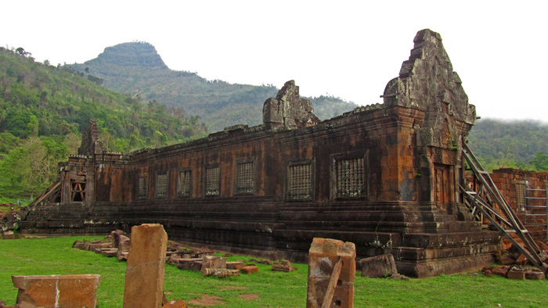
This is an ancient temple which was formerly known as Khamer temple. It is located on the west bank of the Mekong River, South of Pakse. Wat Phou is translated to “mountain temple”. It was built during the late 10th and early 11th century. Over the following centuries, there were added structures in the temple until the 14th century (McDaniel, 2018). This temple was initially dedicated to Shiva. Shiva is one of the gods of the Hindu Trimurti. However, the temple got converted into a Buddhist monastery. The temple is still used as a place of worship by the local Buddhists.
Just like most of the Khmer temples, the Wat Phou temple orientates towards the east. The axis of the temple faces eight degrees south of due east. This is determined by adjusting to the positions of the mountain and the river. The temple, including the brays, stretches a length of 1.4 kilometers east from the base of the cliff (Ooi, 2004). The city is located six kilometers east of the temple, on the west bank of the Mekong. There are also other temples to the south of Angkor city.
When the temple is approached from the city, the visible part or portion of the temple that is seen consists of several betrays. However, there is only one that is filled with water. It measures 600 by 200 meters and it is the middle baray which lays directly along the axis of the temples (McDaniel, 2018). Similar reservoirs (in terms of layout and construction) are located north and south of the first one.
Two palaces stand on a terrace on either side of the axis. They are referred to as the “north and south” palaces or men’s and women’s palaces. However, no one has ever known the reason behind the designated men’s and women’s palaces. Each of the palaces contains a rectangular courtyard which has a corridor and entrance on the sides. There are also false doors at the east and west ends. The courtyards of both palaces have laterite walls. The walls of the northern palace’s corridor are also laterite and those of the south are made of sandstone (Brukoff & Jessup, 2011).
The path leading to the temple ends with seven sandstone tiers which rise to the upper terrace and central sanctuary. The sanctuary consists of two sections, with the front section being made of sandstone. The front section contains four Buddha images (Candee & Bigham, 2011). On the other hand, the brick rear section stands empty with a missing part. The missing part at the rear part is called linga. Since the roof has been collapsing, there has been made a makeshift that covers the front part.
Since the temple was constructed at the cliff of a mountain, there is water that flows into the temple. The water was channeled from a height of 60 meters and directed along a stone conduit into the rear chamber. The water continuously baths the linga. The temple has three doorways. There is the south to north which have pediments displaying Krishna overpowering the naga Kaliya, Indra riding the Airavata, and Vishnu who is riding the Garuda (Candee, et al., 2011). The east wall side shows carvings of dvarapalas and devatas (Ooi, 2004). Besides, both north and south entrances have inner as well as outer lintels and not excluding one to the south showing Krishna tearing Kamsa apart.
There are other features in the area surrounding the temple. They include a library that is located to the south of the sanctuary as well as a trinity to the northwest. There are also some additional carvings situated further in the north and include a print belonging to Buddha on the cliff-face and boulders which have been shaped in a way that resembles a crocodile and an elephant.
The Angkor Wat Temple
Angkor Wat has some similarities and differences to the Wat Phou. It was built to resemble Mount Meru which is regarded by many locals as the home of the gods. It has five towers which were built intentionally in that way so that they could symbolize Mount Meru. The five towers represent the five peaks of Mount Meru (In Bruntz & in Schedneck, 2020). By the time it was being constructed, the Khmer had already invented and refined their classical architectural style. They relied on sandstone which was used to build much of the building blocks. Therefore, as a result of the new architectural style, Angkor Wat was built using blocks made of sandstone.

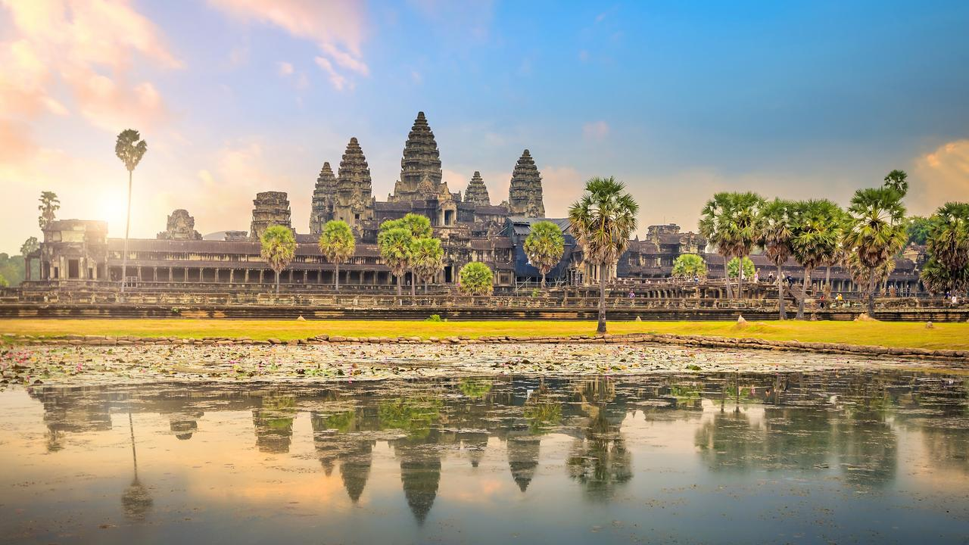
Angkor Wat is surrounded by 15-foot high walls that protected the city, the temple as well as the residents from invasion (Brukoff, et al., 2011). There was also a sandstone causeway that served as the main access path leading to the temple. Inside these high walls, Angkor Wat covers more than two-hundred acres. This is the area that housed the city, the temple structure as well as the emperor’s palace. This is similar to the plan that was used when the Wat Phou was being built.
The Angkor Wat was built in the 13th century in Cambodia and it followed the tradition at the time. The city’s outer walls as well as the temple were the only structures that were made of sandstone. The rest of the structures were made of wood and other less durable materials. This was not entirely similar to the materials that were used to put up the Wat Phou temple and the rest of the other structures. The Wat Phou temple was made of entirely stone materials. This differed to Angkor Wat temples and the surrounding since some sections were made of wood and some other less durable materials (Candee, et al., 2011).
The two temples are similar since they all had water reservoirs. Wat Phou was built in an area where there was water flowing down the mountain. The water was taped and directed into conduits that led to the place where it continuously bathed the Linga. When it comes to the Angkor Wat temple, it was being built just adjacent to an island where they could draw water to be stored in the reservoir tank build in the temple.
The two temples were built in honor of the gods, Vishnu and Buddhist. The walls share some decorations. For instance, the decorations in both temples indicate Vishnu and the Asuras. For instance, proceeding from the western entrance of the temple, the bas reliefs show the Battle of Kurukshetra, King Suryavarman’s Victory procession, the Battle of Vishnu with the Asuras, and the battle of Krishna with the Demon Bana (In Bruntz, et al., 2020). Besides, the Angkor Wat temple is oriented to the west rather than the east. This is different from most of the temples built in the region. For instance, the Wat Phou temple is oriented to the east.

References
Brukoff, B., & Jessup, H. I. (2011). Temples of Cambodia: The heart of Angkor. Bangkok: River Books.
Candee, H. C., & Bigham, R. B. (2011). Angkor the magnificent: Wonder city of ancient Cambodia. Holmes Beach, FL: DatASIA.
In Bruntz, C., & In Schedneck, B. (2020). Buddhist tourism in Asia.
McDaniel, J. (2018). Architects of Buddhist Leisure: Socially disengaged Buddhism in Asia's museums, monuments, and amusement parks.
Ooi, K. G. (2004). Southeast Asia.[Volume two, H-Q]: A historical encyclopedia from Angkor Wat to East Timor. Santa Barbara, Calif: ABC-CLIO.

